Chapter 12, Solution 33.

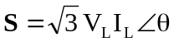

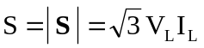

For a Y-connected load,
 